Jennifer Stegina

2 September 2019

CIS 250

**Unit 2 Graded Exercise 1**

The following questions come from the “Check your understanding” examples of each section of chapter 3 in your textbook. After you are finished, please submit a Microsoft Word file that contains screenshots of the SQL script and the resulting tables, and a comment line in each Query that contains your name. Your document should be named **U2_GradedExercise1_Lastname.docx**.

(3-1) Question 1

List all the rows of the *l_foods* table that have a price less than $1.00 or greater than $5.00.

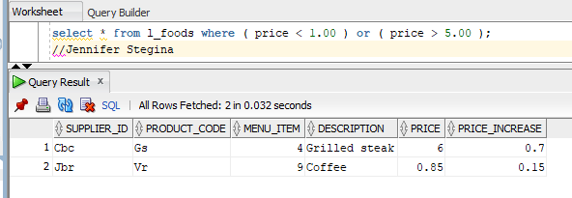

(3-2) Question 2

List all the foods from the *l_foods* table that do not have a null in the *price_increase* column.

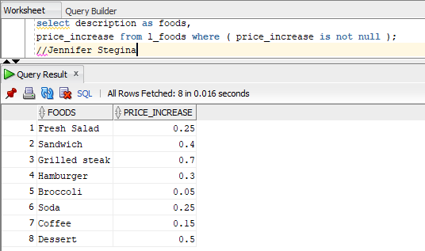

(3-3) Question 3

Put the following where clause into standard form:

*select \**

*from l_employees*

*where not ((first_name = 'JIM' or first_name = 'DAN')*

*and (last_name = 'BROWN' or last_name = 'SMITH'))*

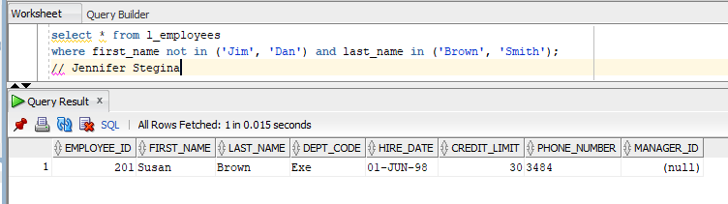

(3-4) Question 4

Add parentheses to the following select statement to prevent it from making a common mistake.

*select \**

*from l_foods*

*where description = 'FRESH SALAD'*

*or description = 'SANDWICH'*

*or description = 'DESSERT'*

*and price <= 2.50*

*and price_increase <= 0.25;*

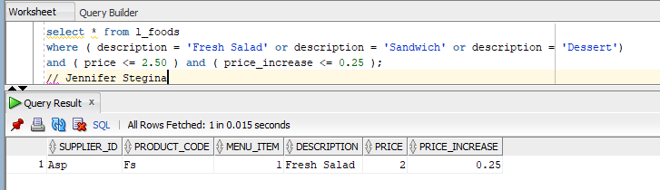

(3-6) Question 5

Modify the following *select* statement to remove the hard-coded values $1.00 and $2.00 from the code and place them in a table of constants.

The table *sec0306_price_constants* is already set up for you. The *min_price* field = 1.00 and the *max_price* field = 2.00.

When I make a change like this, in addition to replacing the hard-coded values, I often put those values in the select clause so I can see exactly what the values are whenever I run the SQL code.

*select description*

*from l_foods*

*where price between 1.00 and 2.00*

*order by description;*

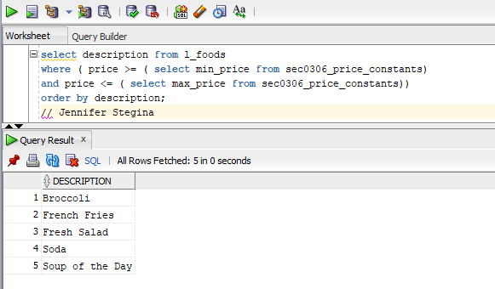

(3-7) Question 6

Find and correct the error in the following:

*select \**

*from l_suppliers*

*where supplier_name = 'frank reed's vegetables';*

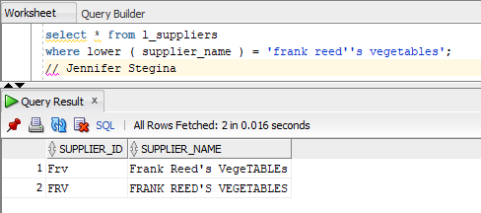

(3-9) Question 7

Add the word “upper” to the following code to make it work regardless of how the name is capitalized in the data.

*select \**

*from employees*

*where last_name = 'de haan';*

We do not have a table named employees. There is not an individual with the last name of de haan in our table named l_employees. I wrote the query and tested it with an existing name to verify it worked. ‘de haan’ query below.

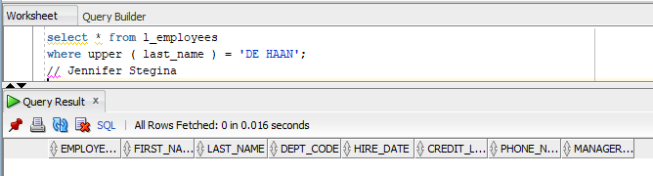

(3-17) Question 8

Start with any select statement that works. On purpose, change it so that it

does not work anymore. See how well the error messages can tell you what the problem is.

Works

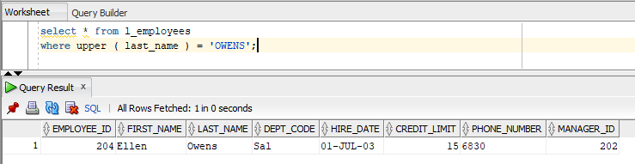

Does NOT work

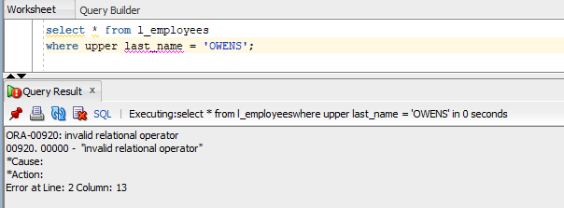

This is giving me an ‘indvalid relation operator” because there are not parentheses around last_name and sql sees two separate things before the equal sign and doesn’t know which to compare.